Answer1 :

create table author(

author_id INTEGER primary key not null,

first_name varchar(20) not null,

last_name varchar(20) not null

) ;

create table publisher(

publisher_name varchar(20) primary key not null,

city varchar(20) not null,

country varchar(20) not null

) ;

create table book(

book_id INTEGER primary key not null,

title_name varchar(20) not null,

price INTEGER not null,

publisher_name varchar(20),

foreign key (publisher_name) references publisher(publisher_name)

);

create table author_book(

id integer primary key,

book_id integer,

author_id integer,

foreign key (book_id) references Book(book_id),

foreign key (author_id) references Author(author_id)

);

**Insert Data :-**

insert into author ('author_id', 'first_name', 'last_name') values (1, 'r','kumar');

insert into author ('author_id', 'first_name', 'last_name') values (2, 'r','kumar');

Select * from author;

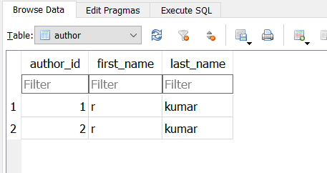

insert into publisher ('publisher_name', 'city', 'country') values ('raj', 'Sirsa','IN');

insert into publisher ('publisher_name', 'city', 'country') values ('sahil', 'Hisar','IN');

select * from publisher,

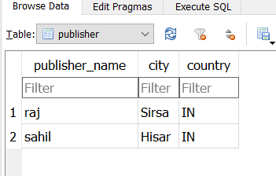

insert into book ('book_id', 'title_name', 'price', 'publisher_name') values (1, 'Week 1', 100, 'raj');

insert into book ('book_id', 'title_name', 'price', 'publisher_name') values (2, 'Week 2', 1000, 'sahil');

select * from book

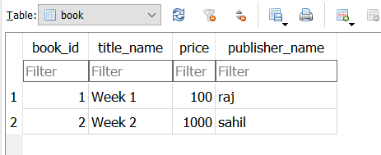

insert into author_book ('id', 'book_id', 'author_id') values (1, 2,1);

insert into author_book ('id', 'book_id', 'author_id') values (2, 1, 2);

select * from author_book

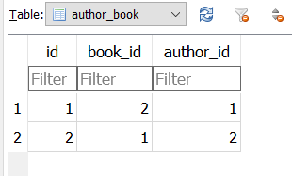

Answer 2:

select Top 3 * from trades as t join users as u on t.user_id = u.user_id having t.status = 'complete' group by u.user_id order by count(u.user_id) desc

Answer 3:

Agile project management is a way of doing work or framework that takes an iterative approach to complete a project. Agile provides several ways to achieve tasks like Scrum project management. It is generally used for large-scale projects, and any feedback from the client can be added on a requirement basis. It is also a suitable option for AI projects because of large-scale and require Front to Backend and AI model integration, where spontaneous changes are very often. Agile provides all features and dynamic updates of any changes in the sprint.